**Django Assignment Webapps Report**

**🡪Below screenshot shows us the home page for web application based on Django which is webapps2023. It also shows that it is a secure communication over the internet as it shows https on the web page. Also, user can signup if they don’t have an account or login if they already have an account.**

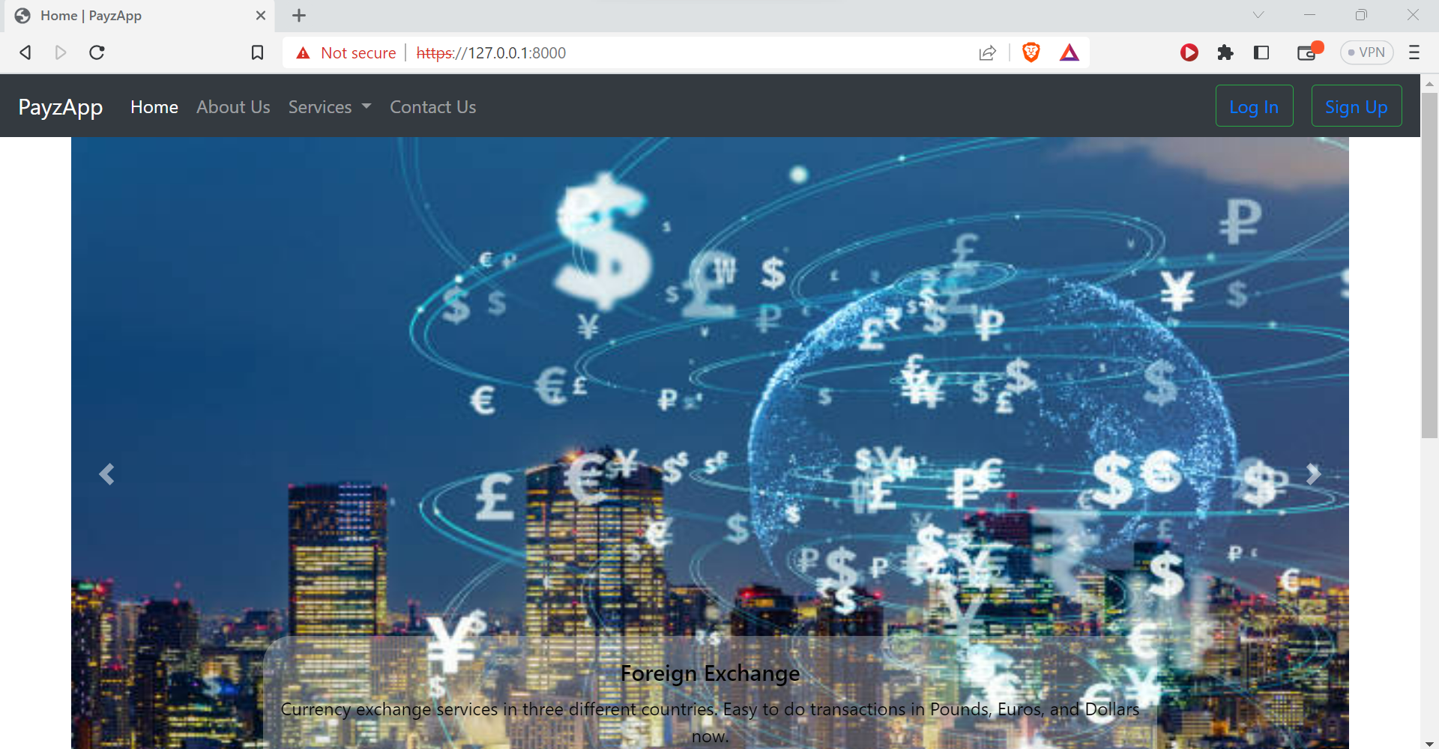

**🡪Below screenshot shows us the about page of this website.**

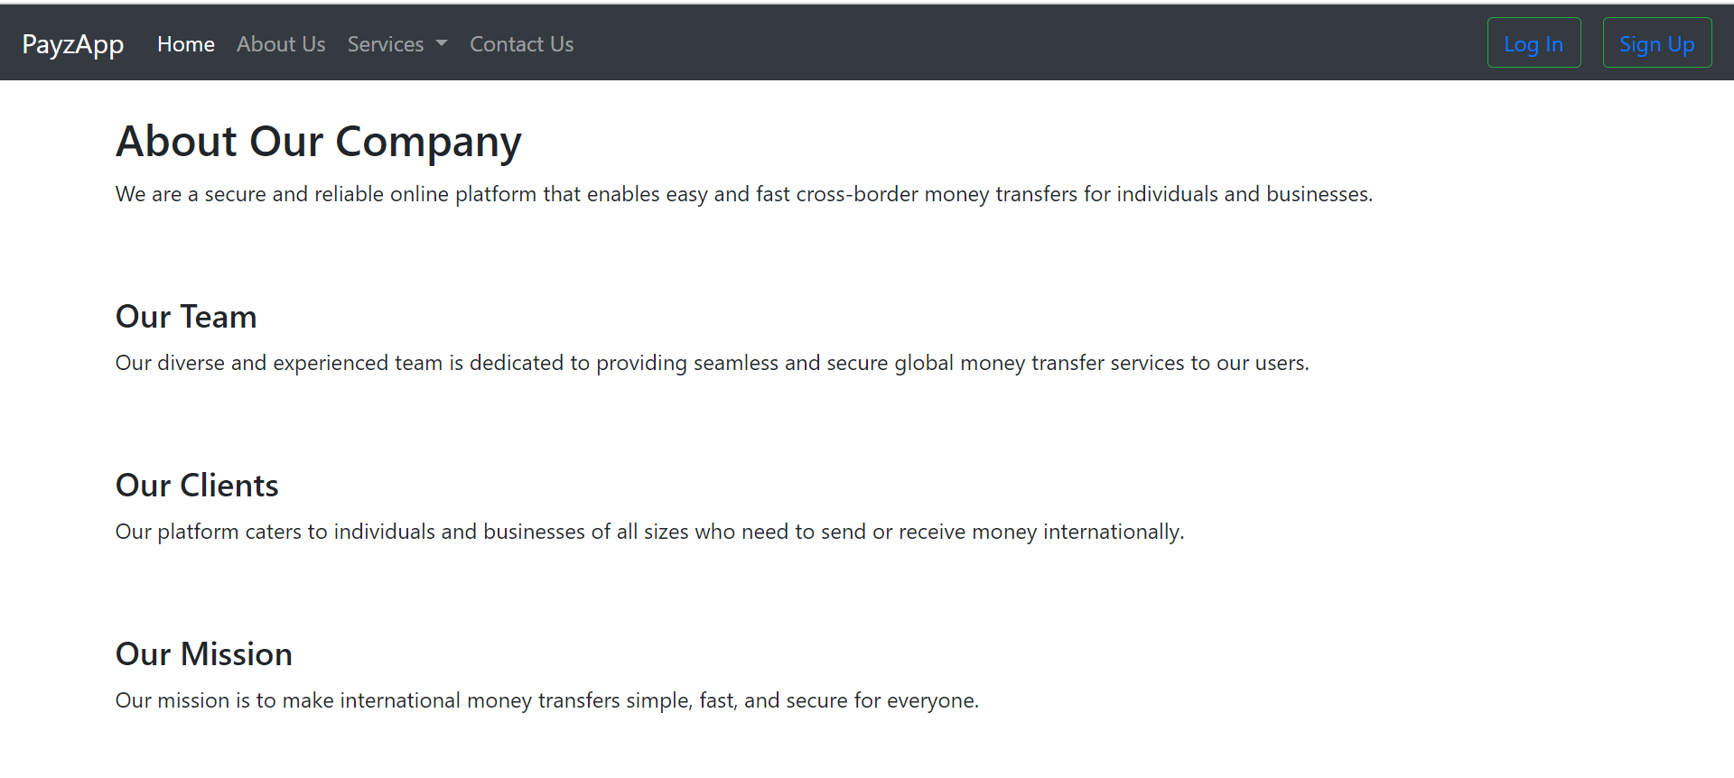

**🡪Below screenshot shows us the contact page for the website where user can send their details to the team and their queries.**

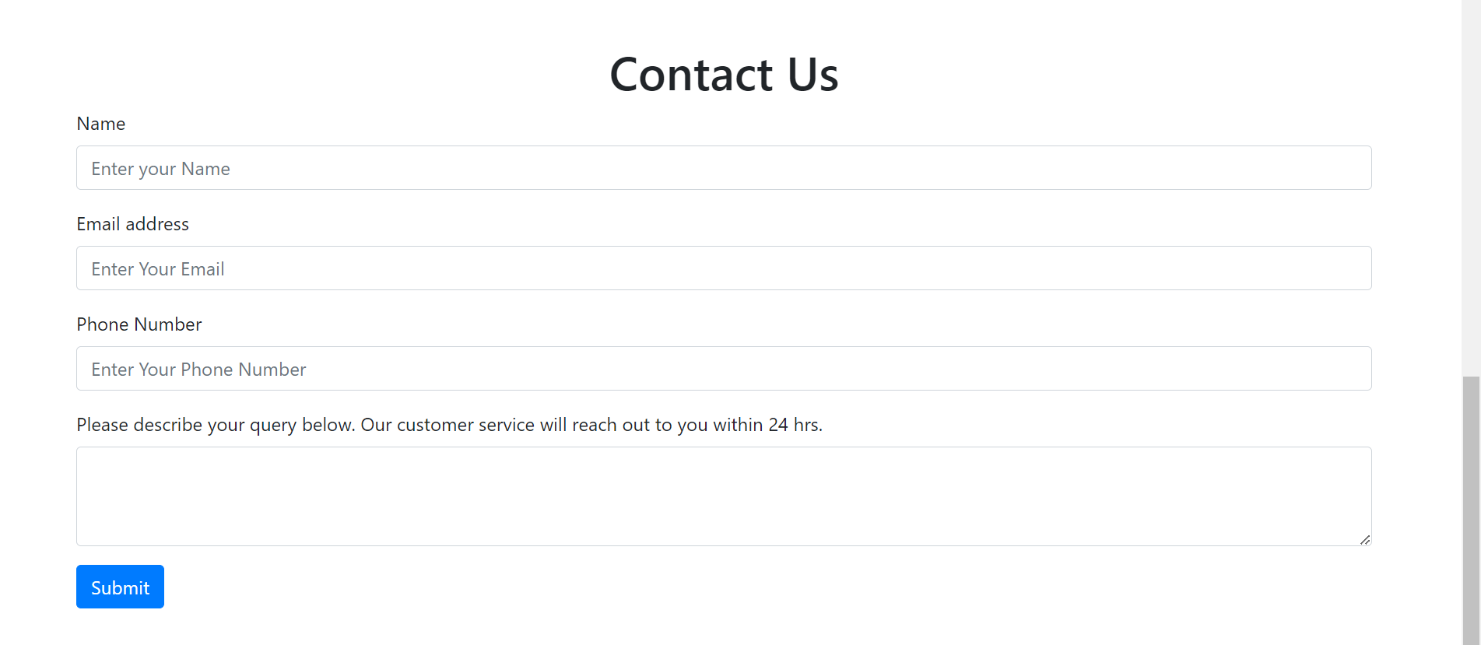

**🡪Below screenshot shows us the admin page for this web apps and admin as named as admin1 here which is also a secure transfer page enabling https here.**

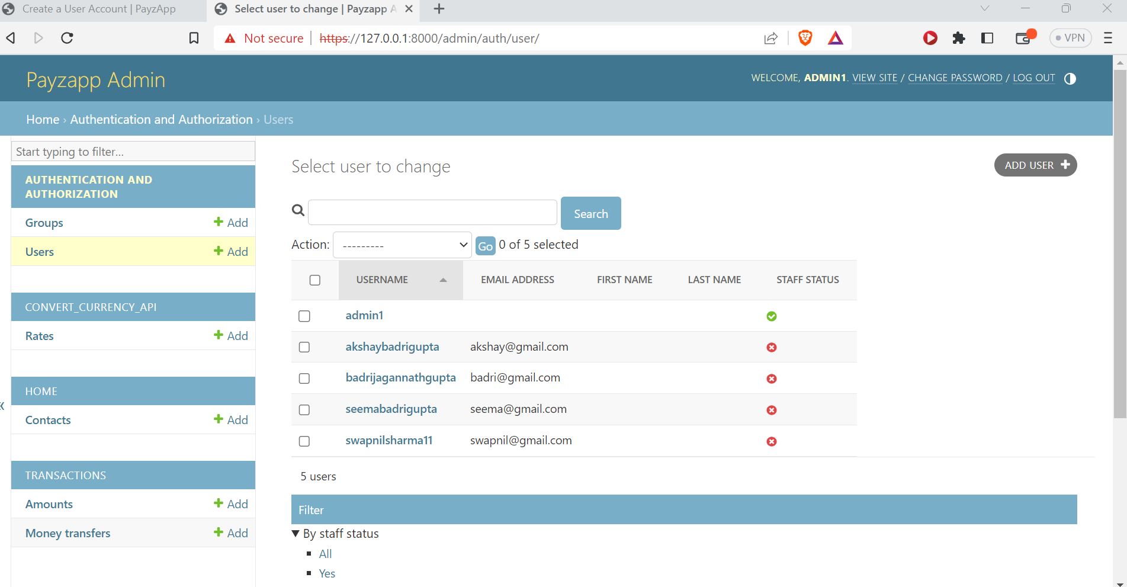

**🡪Below screenshot shows us the project structure and webapps db which is db.webapps.**

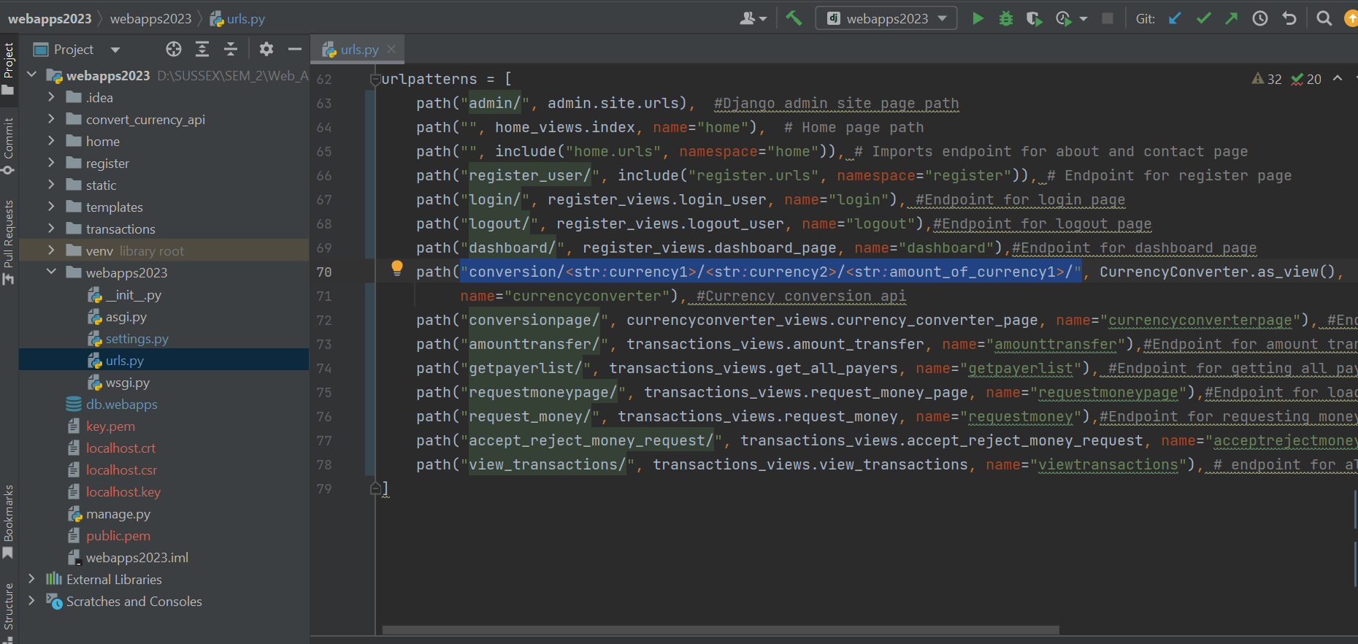

**🡪Below screenshot shows us the signup page where user can give the First name, Last name, email, username, choose their currency and password by securely transferring data to backend.**

**By default users have been assigned 1000 gbp to their currency conversion in their account. Base currency is gbp here.**

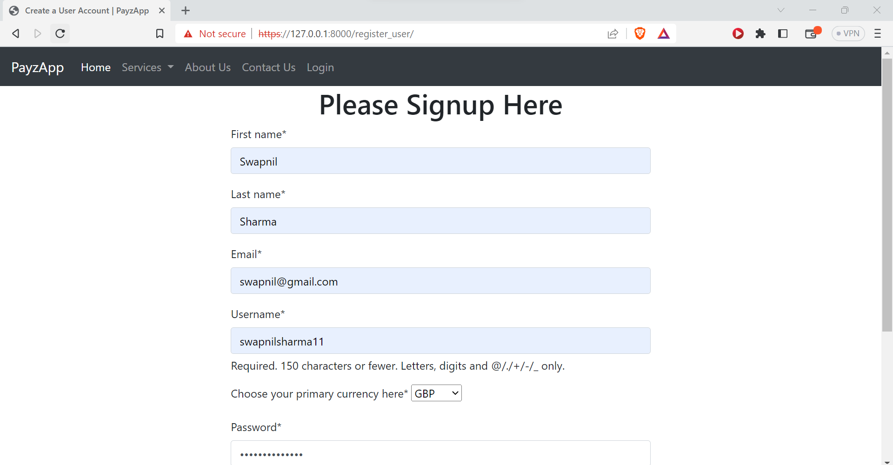

**🡪Below screenshot shows us the full page for sign up page.**

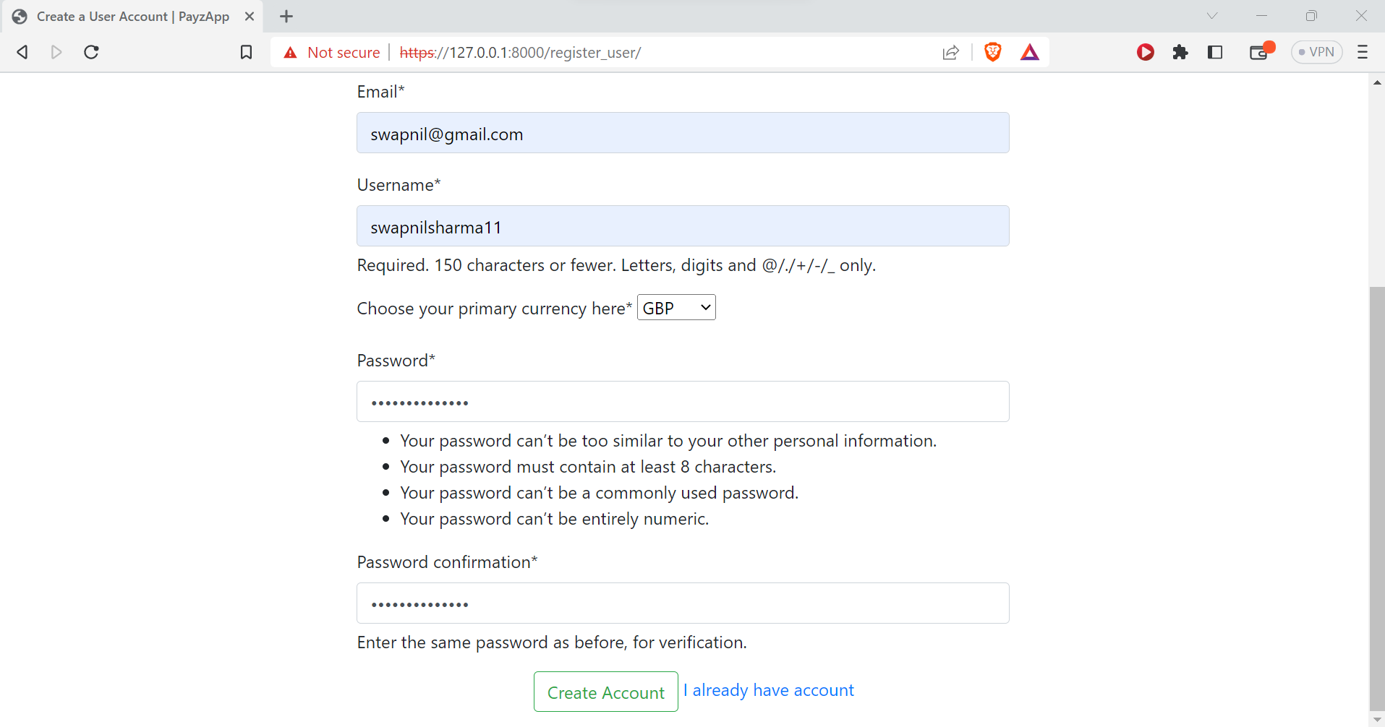

🡪**Below screenshot shows that the conversion/usd/euros/200/ is a secure https get api.**

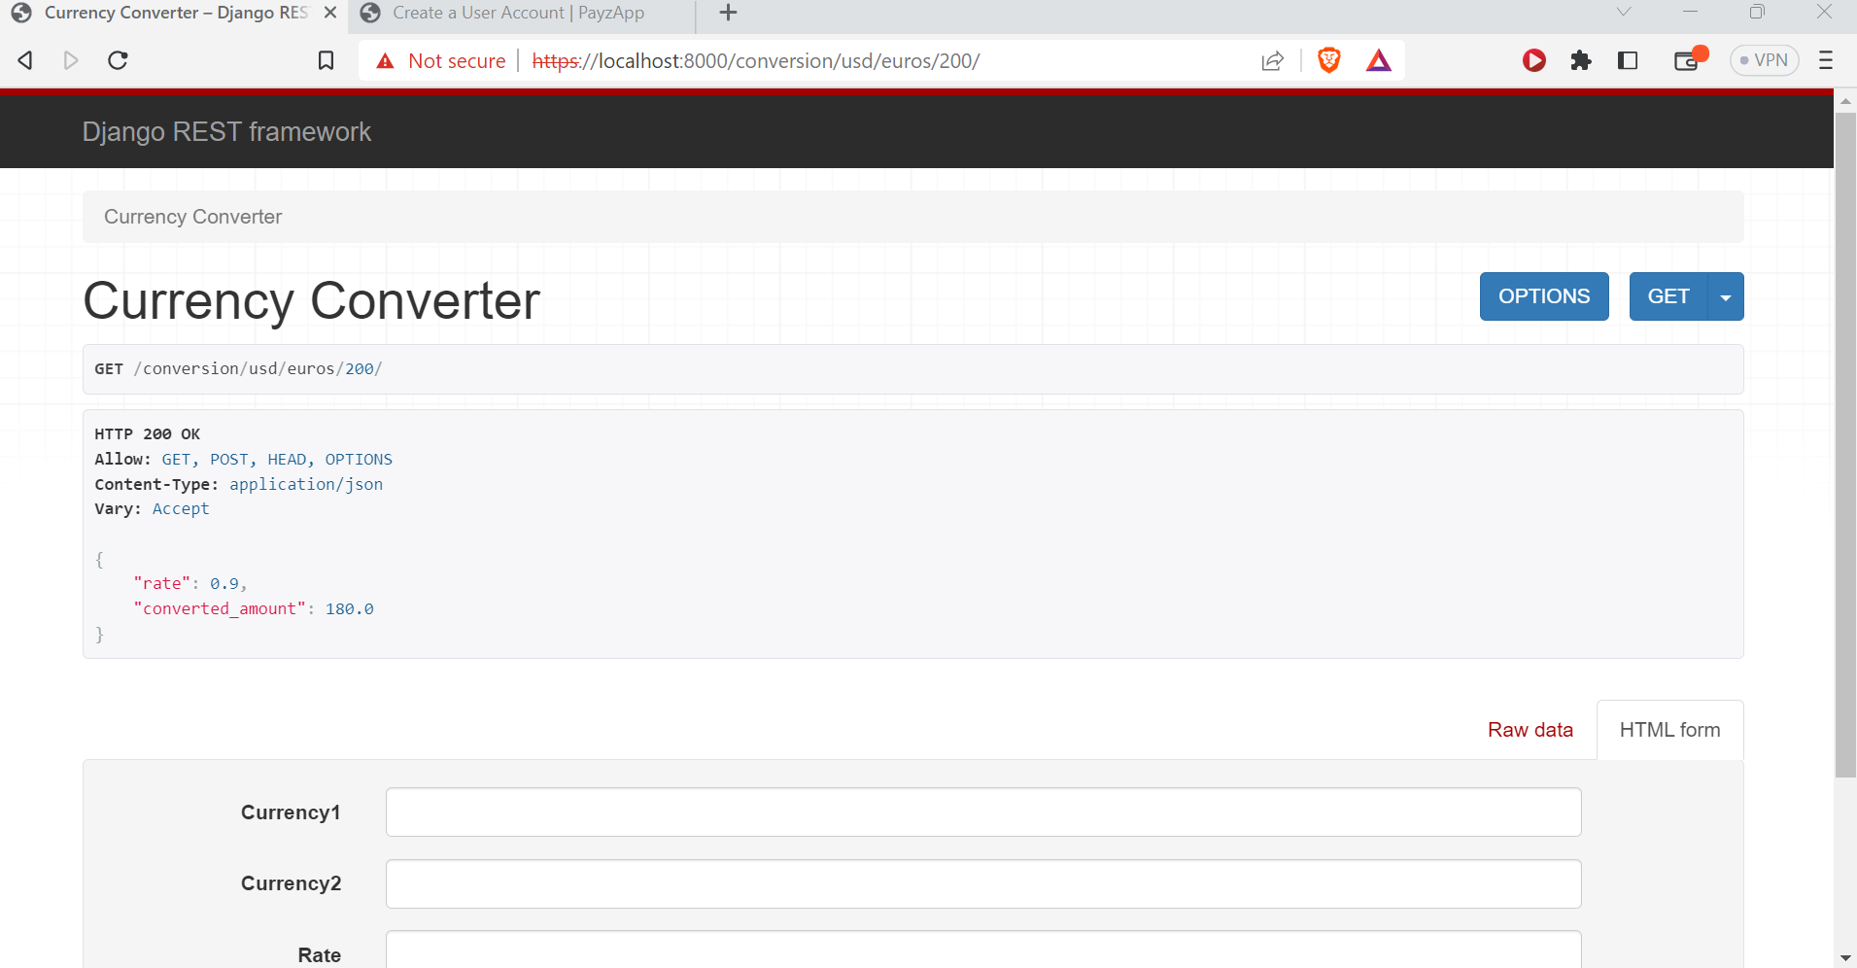

**🡪Below screenshot shows us the cmd prompt screenshot where webapps2023 is running by using certificate and key given name as localhost.**

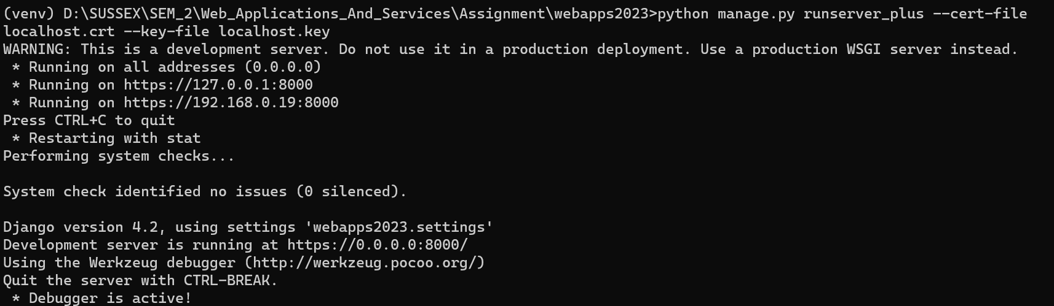

**🡪 Below screenshot shows us the registered models on admin page.**

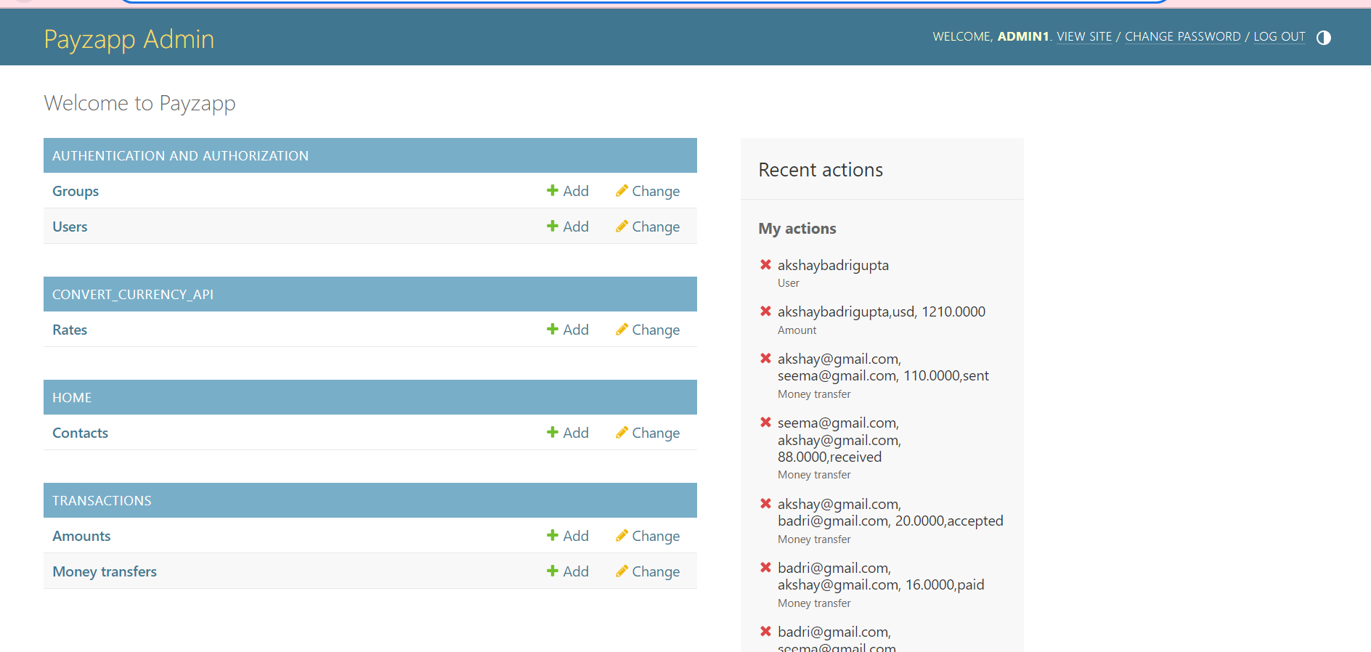

**🡪 Below screenshot shows us the sign up page for new user which we will use for demonstrating all functionalities related to this app.**

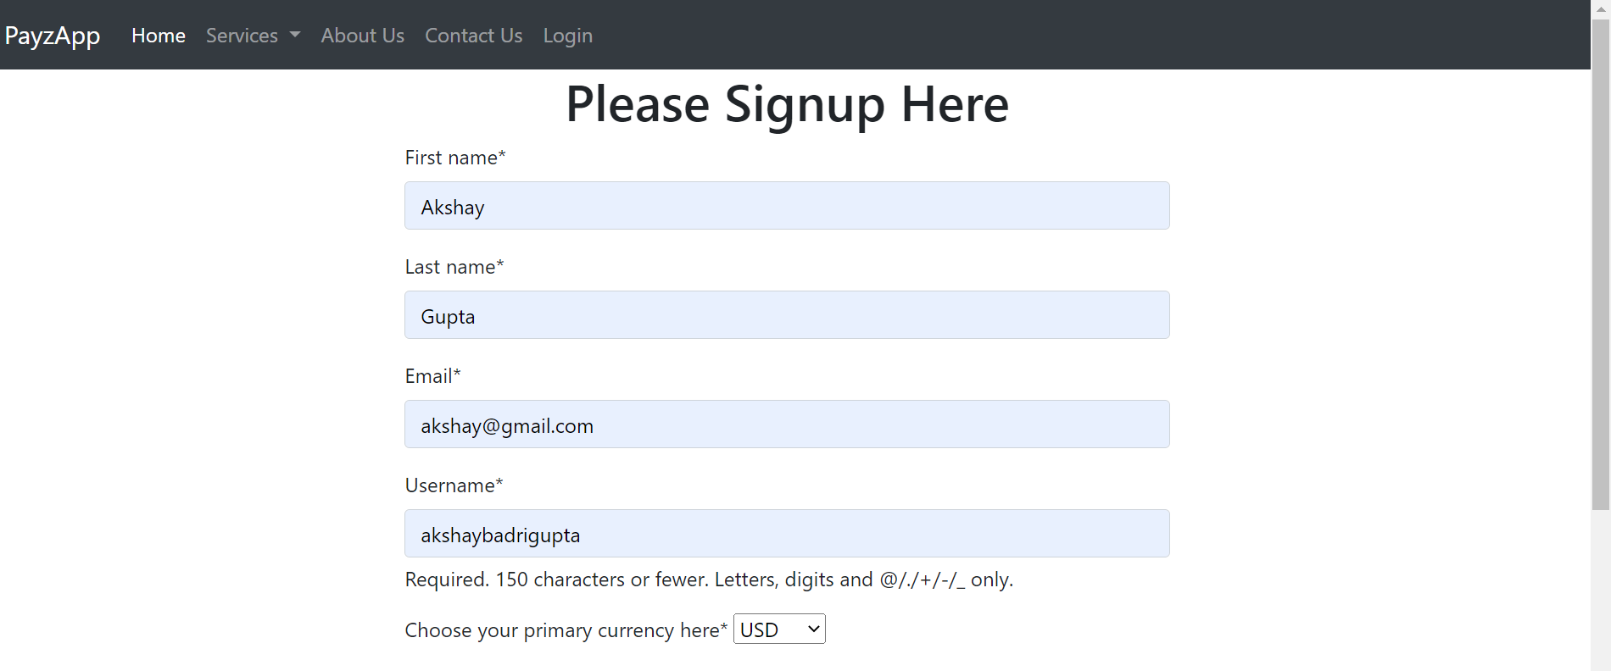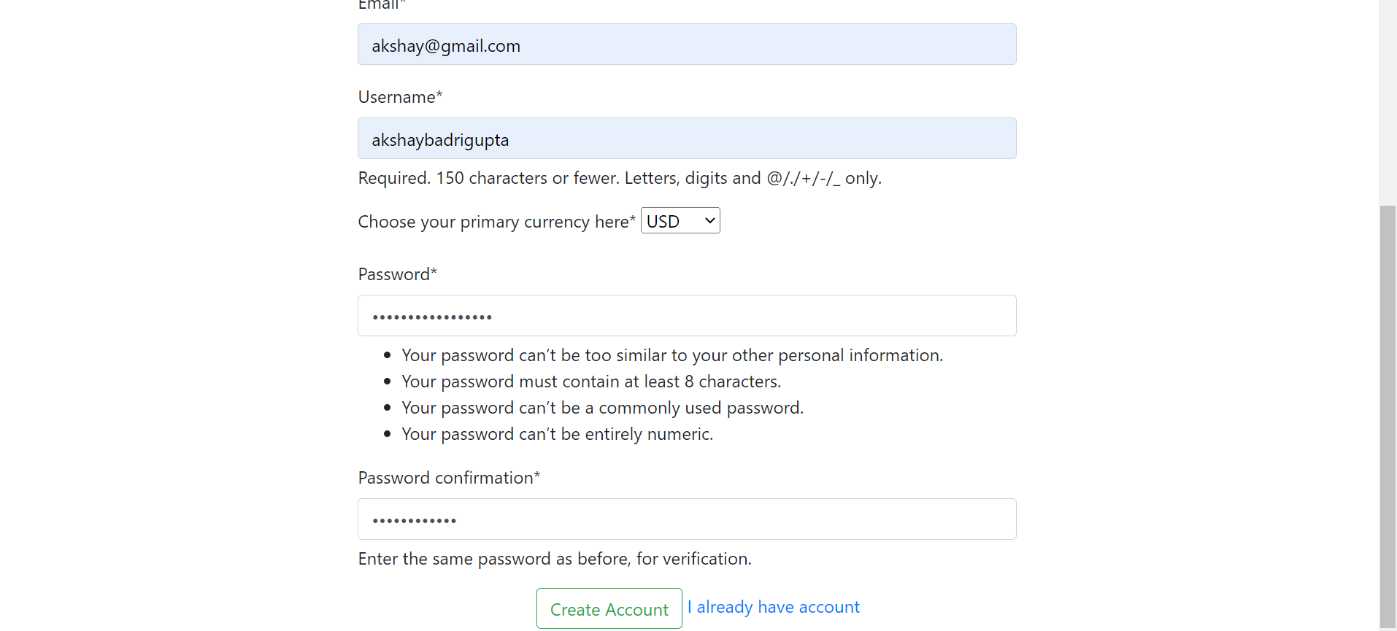

**🡪 Below screenshot shows us the login page for user, user is redirected to login page after signing up successfully.**

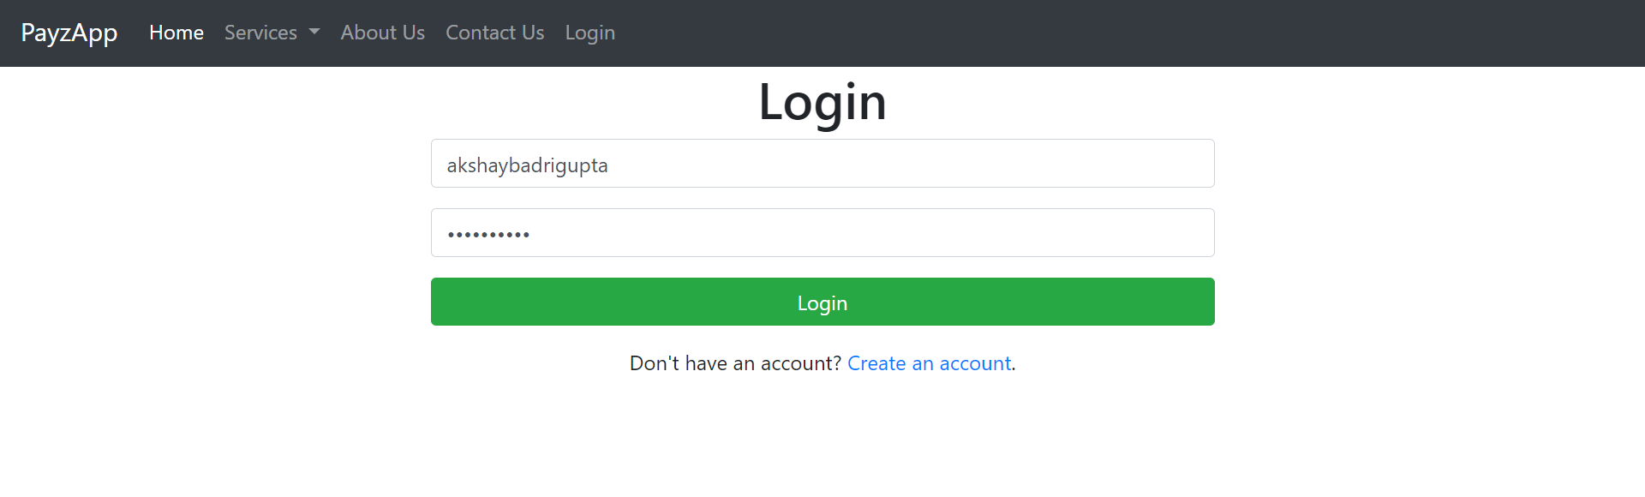

**🡪 Below screenshot shows us the converted amount in usd which is his main balance in his account and his currency.**

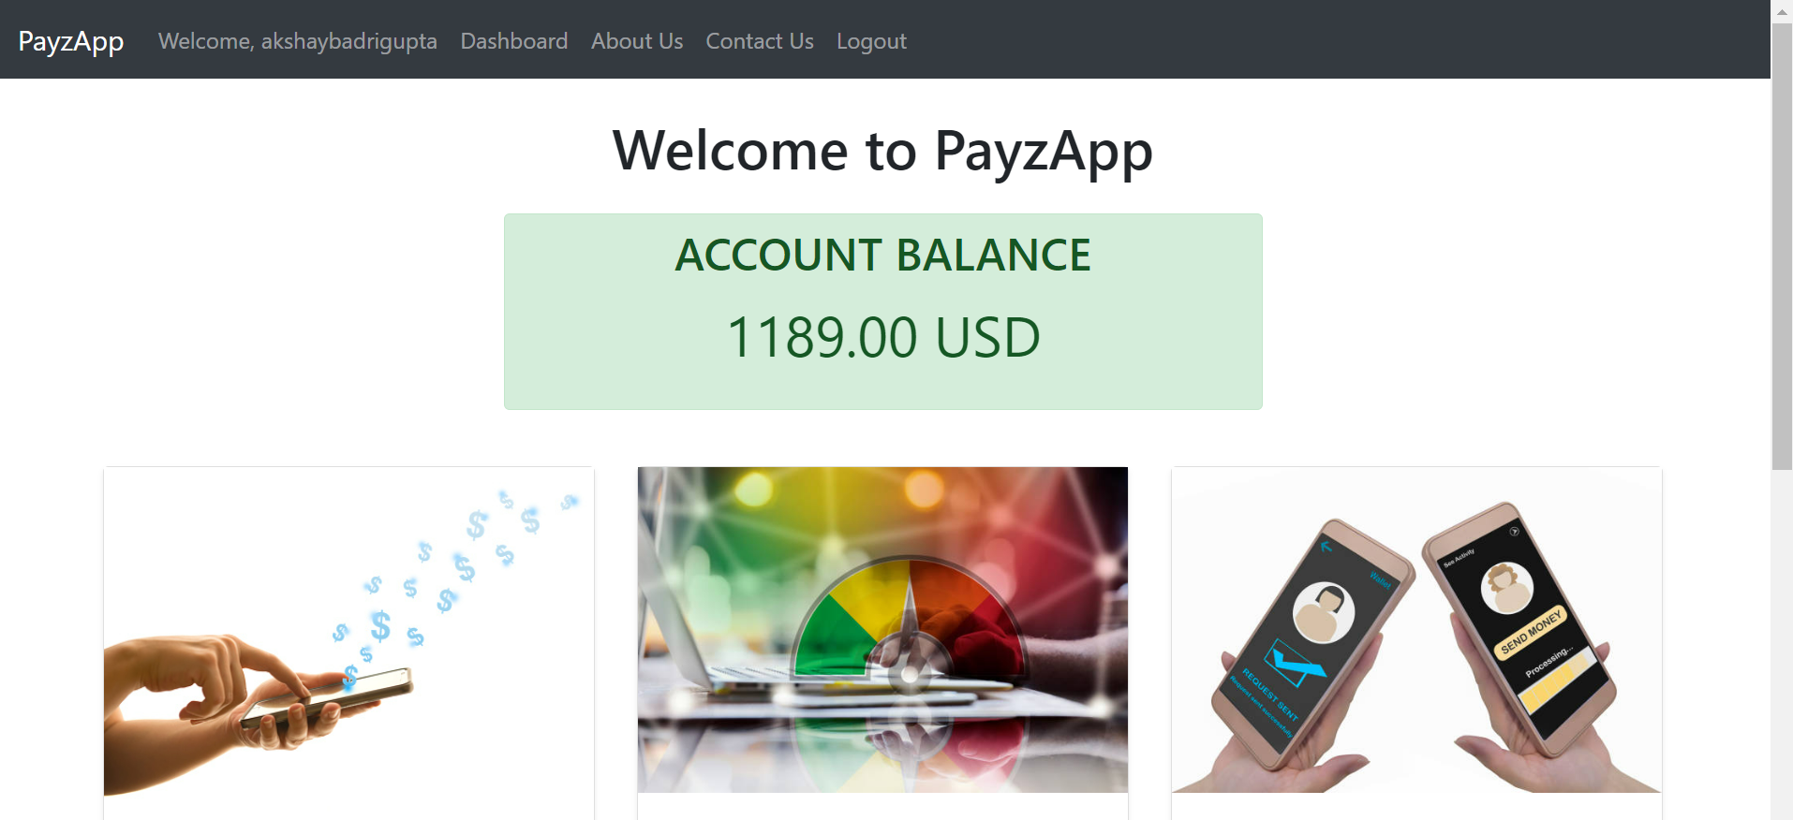

**🡪 Below screenshot shows us the user is transferring amount 34 to seema@gmail.com.**

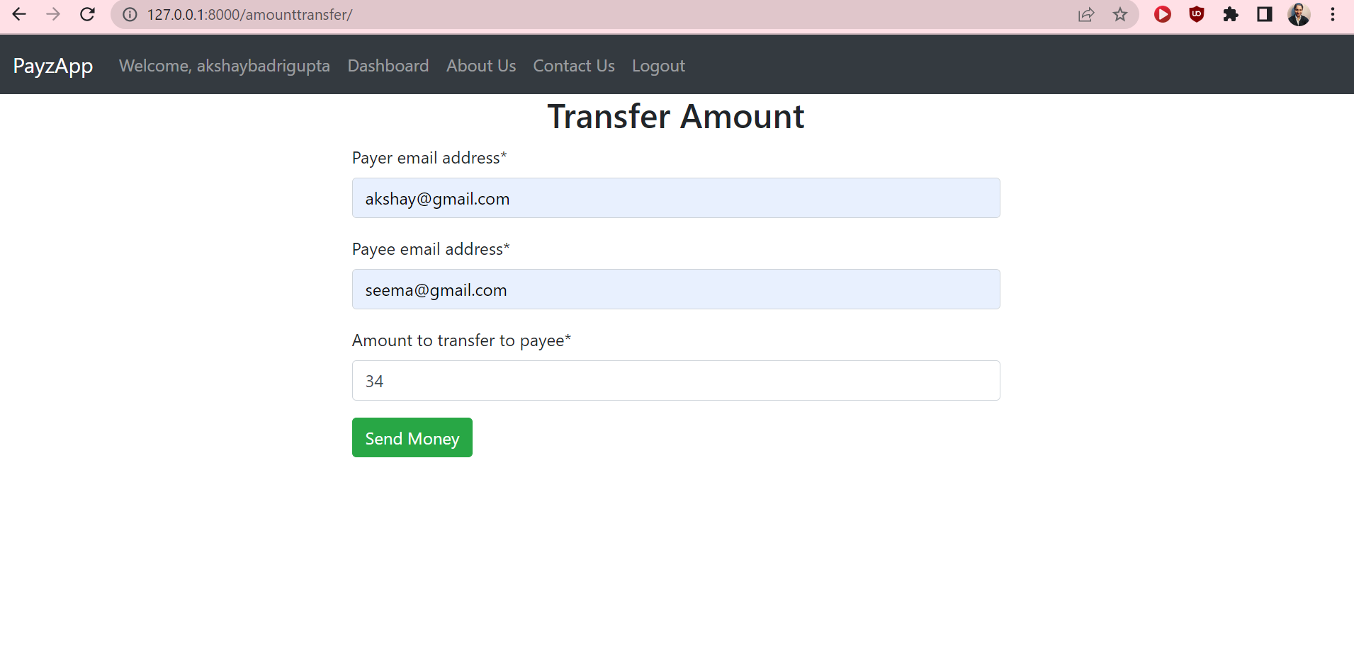

**🡪 Below screenshot shows us that user can view transaction history of amount transactions.**

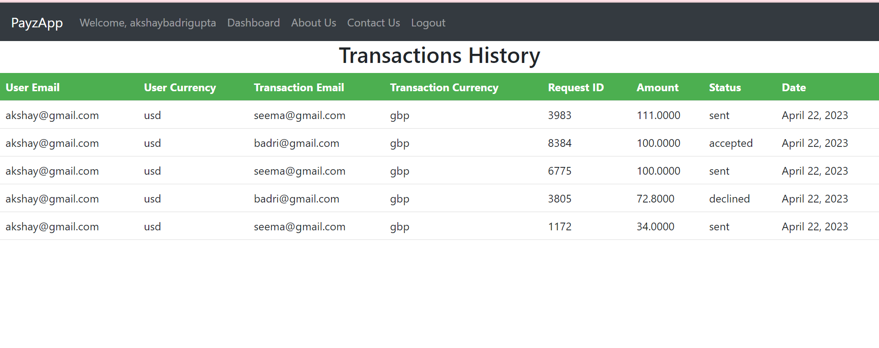

**🡪 Below screenshot shows us that user can request by clicking on request button and that he has accepted request from user badri@gmail.com.**

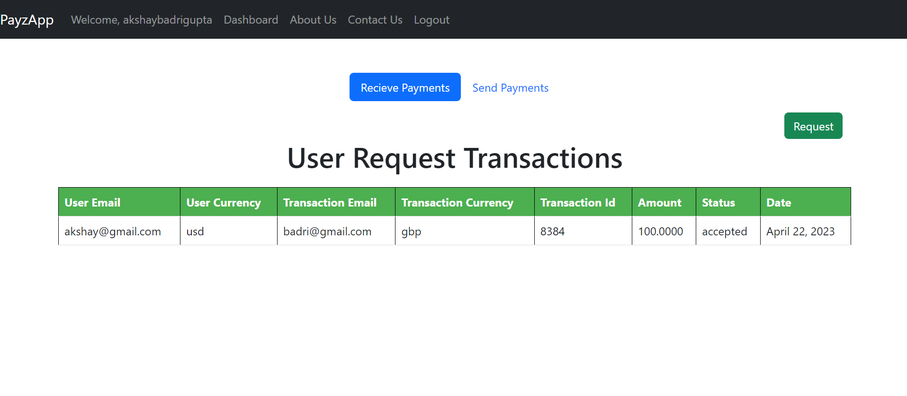

**🡪 Below screenshot shows us that user is requesting money to** [**seema@gmail.com**](mailto:seema@gmail.com) **amount of 34 in his currency.**

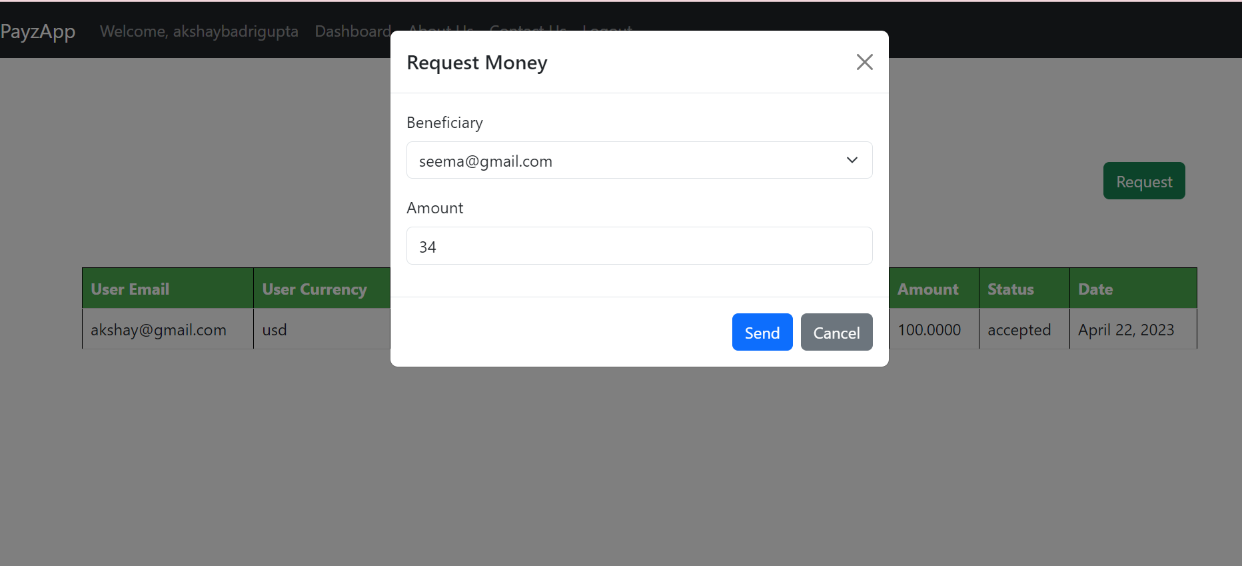

**🡪 Below screenshot shows us that user received a message after creating request and also we can see pending, accepted, rejected request here.**

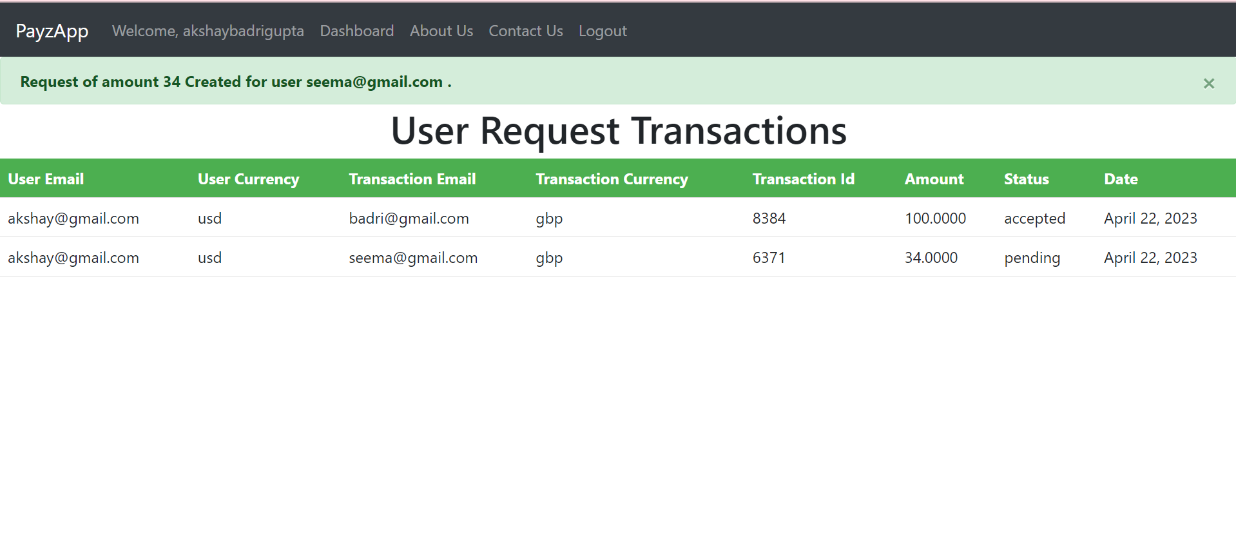

**🡪 Below screenshot shows us that user can send payments from this page where he has got request from all the users .**

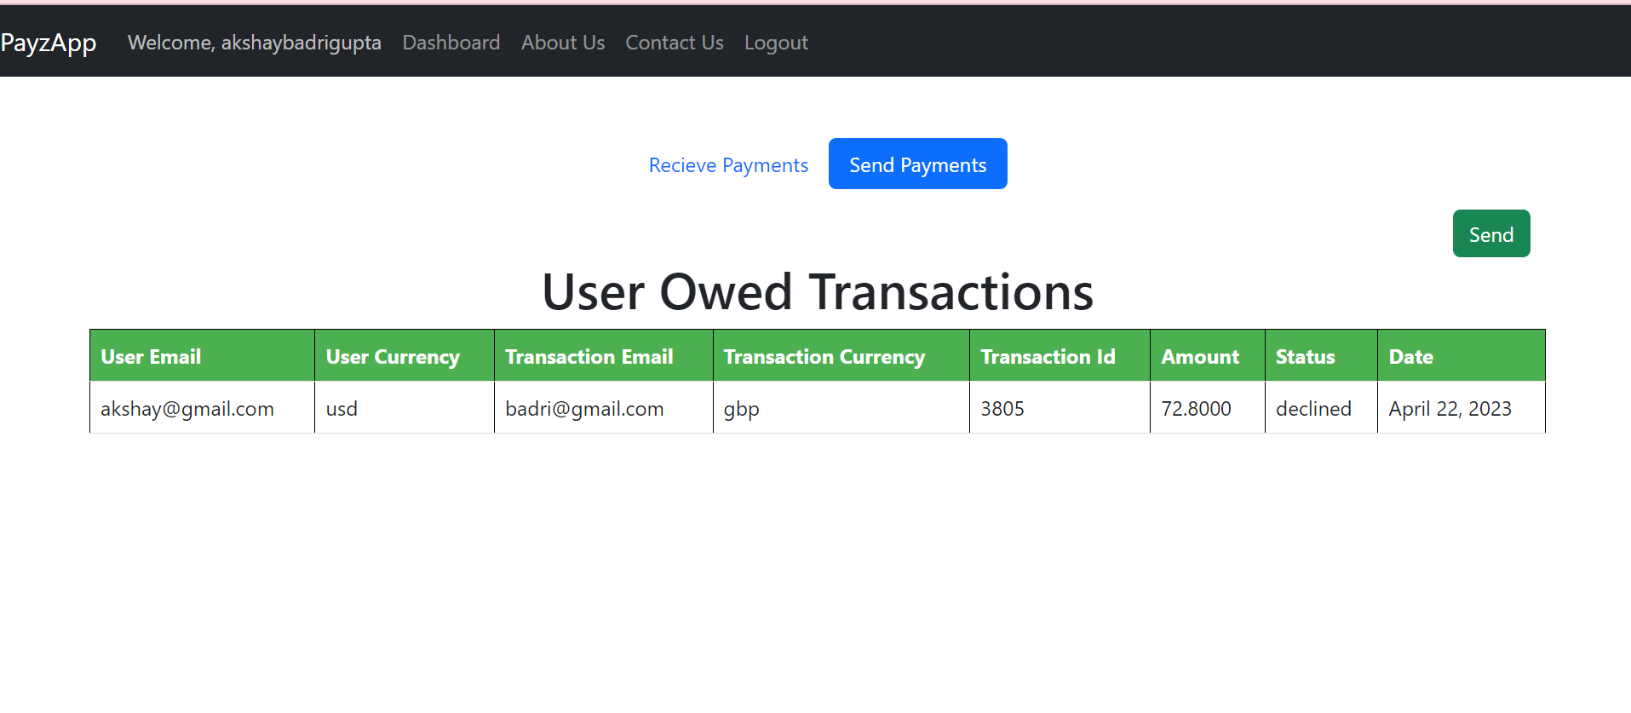

**🡪 Below screenshot shows us that user get message after creating amount request to other user.**

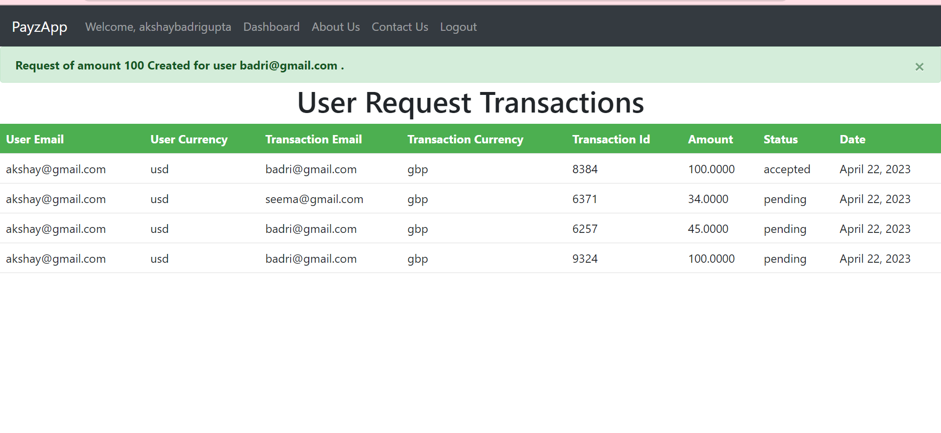

**🡪 Below screenshot shows us that user can convert any amount of currency and get the conversion rate as well.**

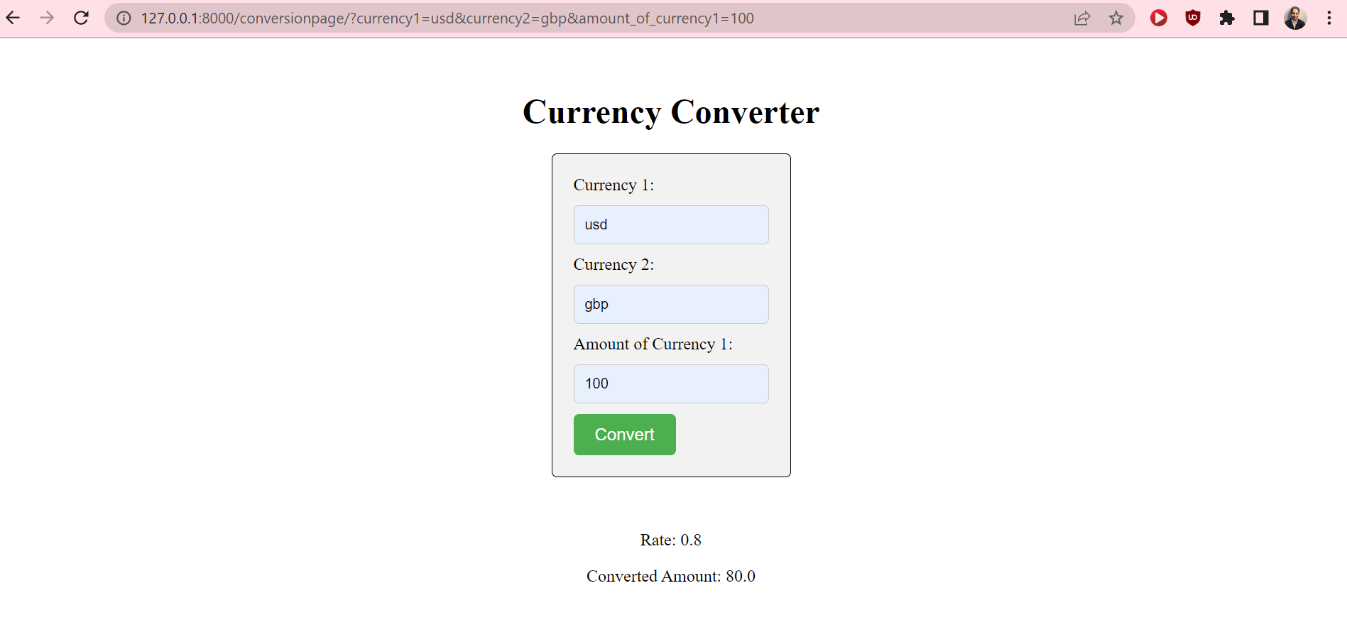

**🡪 Below screenshot shows us that user has received the converted amount.**

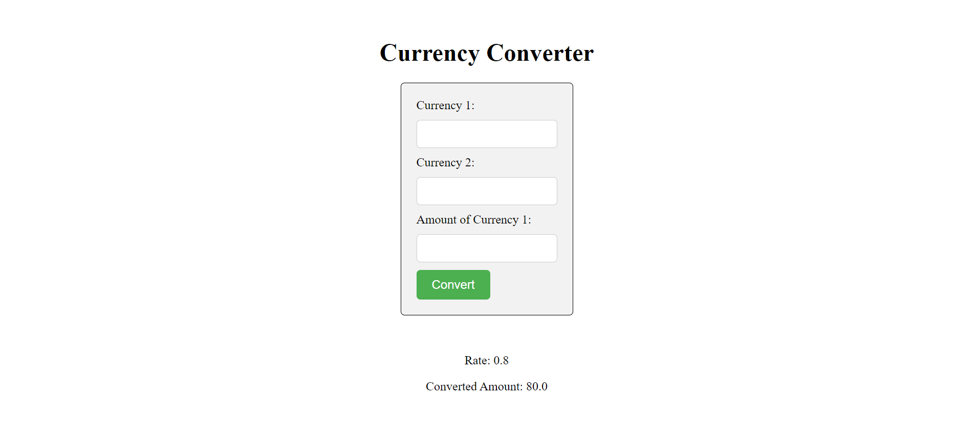

**🡪 Below screenshot shows us that user account balance has been updated after transfers.**

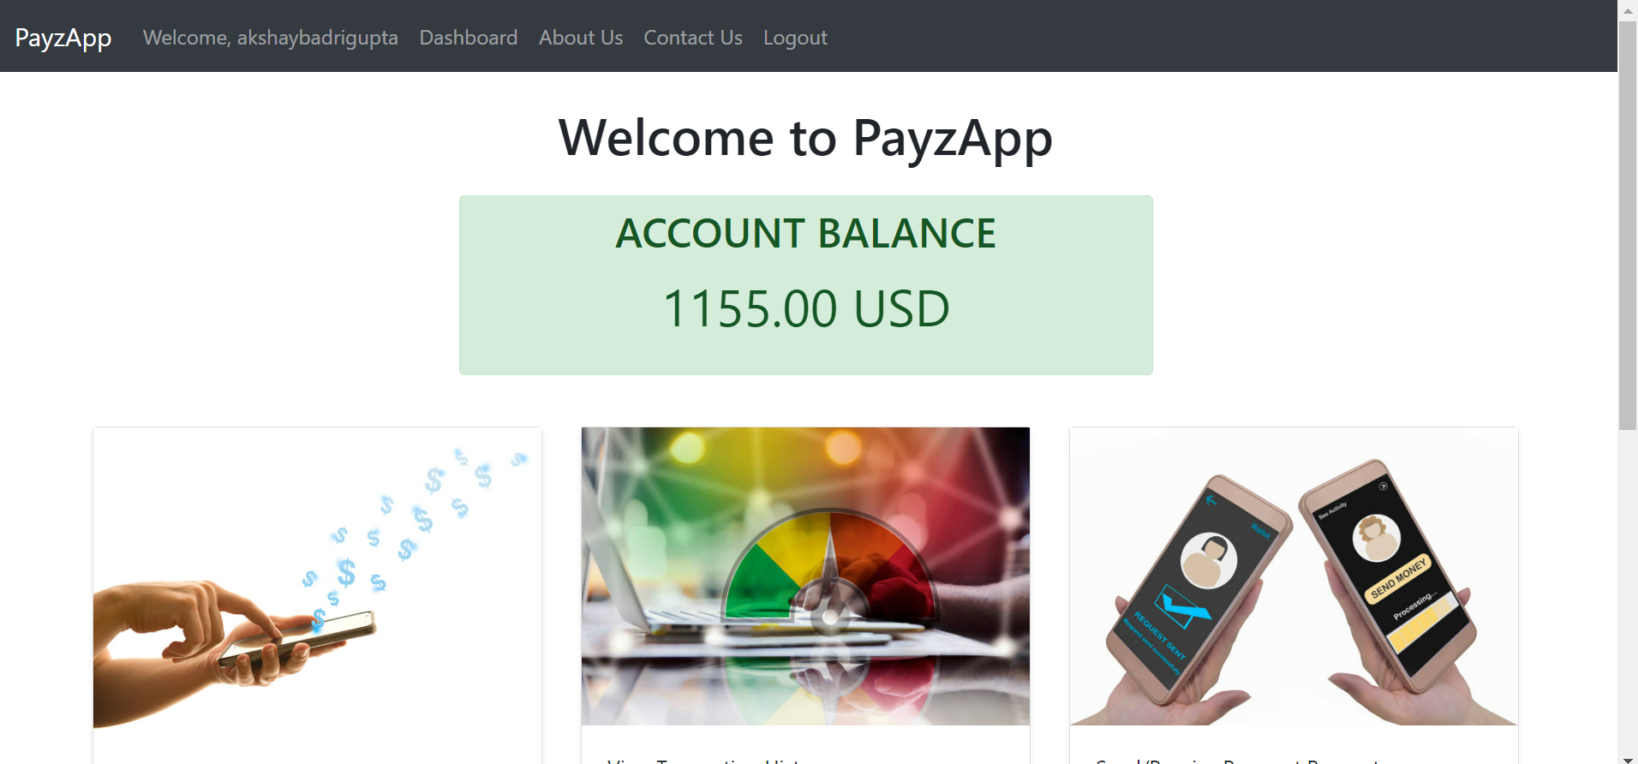

**🡪 Below screenshot shows us that user has logged out successfully.**

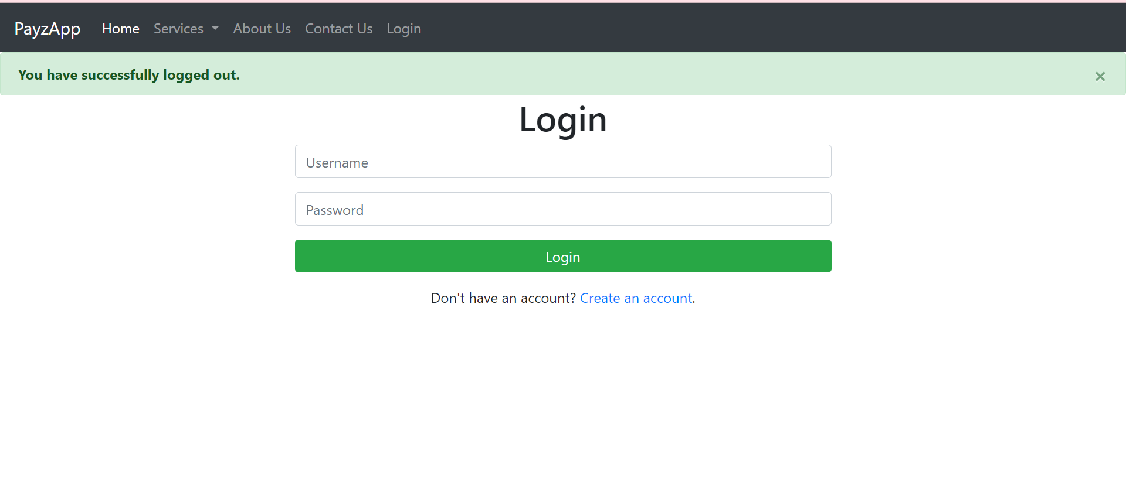

**🡪 Below screenshot shows us that another user logged in where he will accept/reject the request of previous user, so user2 can see their balance after transfers.**

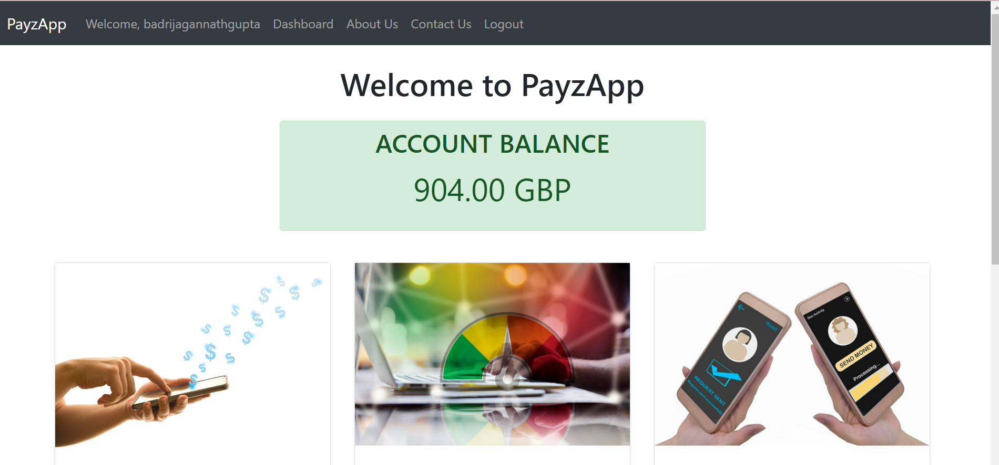

**🡪 Below screenshot shows us that user2 is accepting the request of user1.**

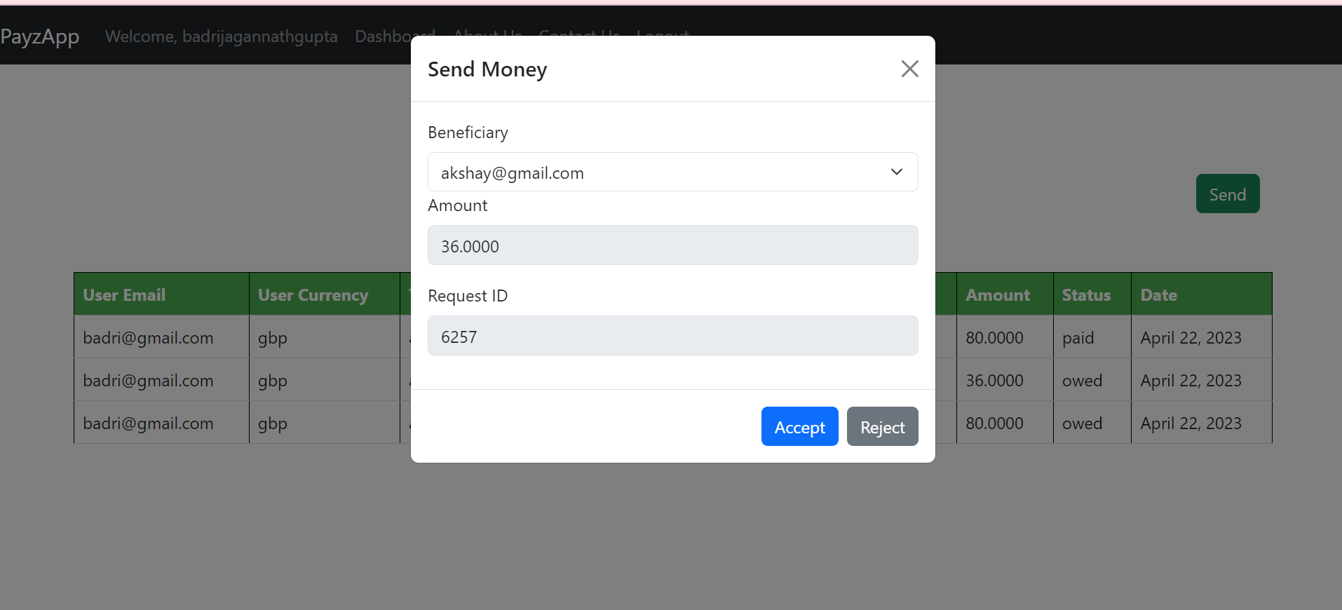

**🡪 Below screenshot shows us that user2 has got the message of successful transfer of money and can view transactions.**

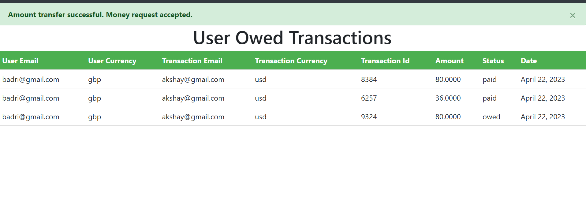

**🡪 Below screenshot shows us that user2 can accept or reject the money request of user1.**

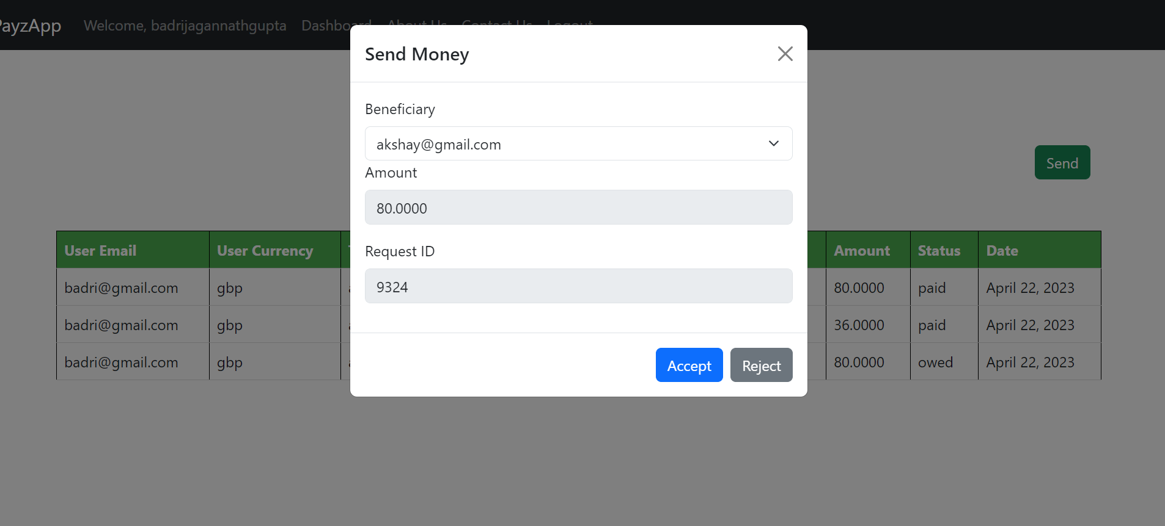

**🡪 Below screenshot shows us that user2 has declined the money payment request of user1.**

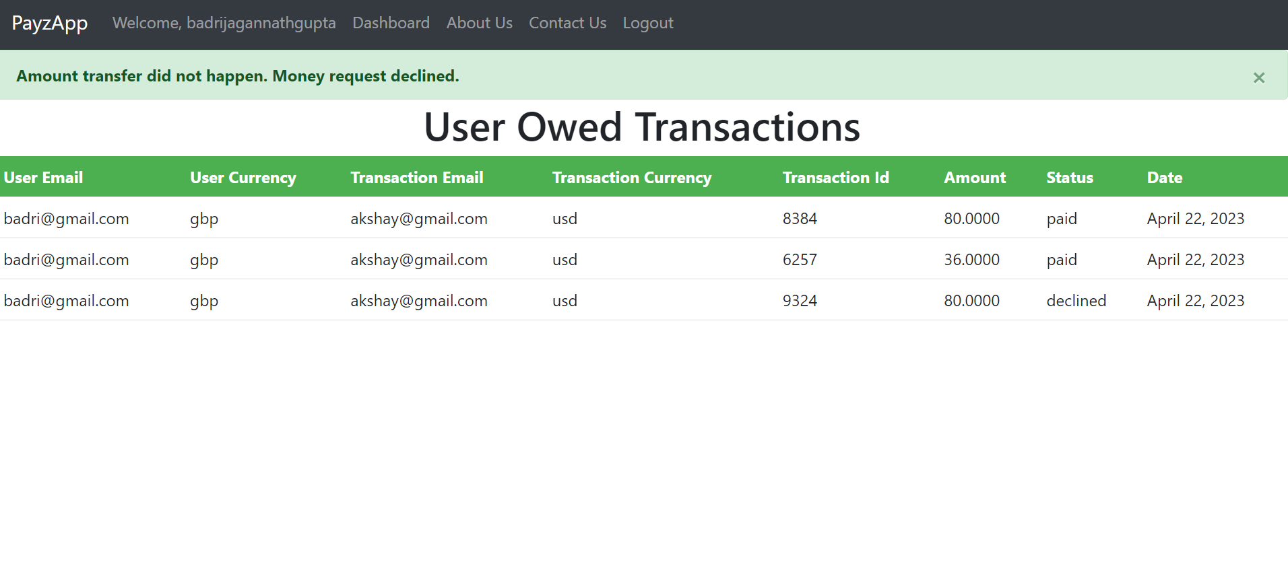

**🡪 Below screenshot shows us the account balance of user2 after accepting, rejecting money requests on this page.**

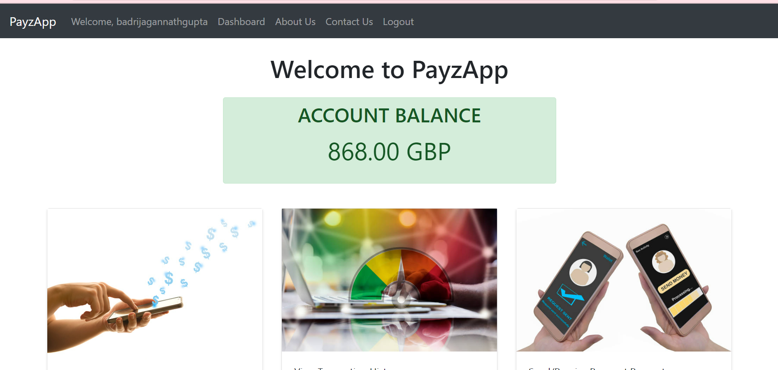

**🡪 Below screenshot shows us the final transaction history of user2.**

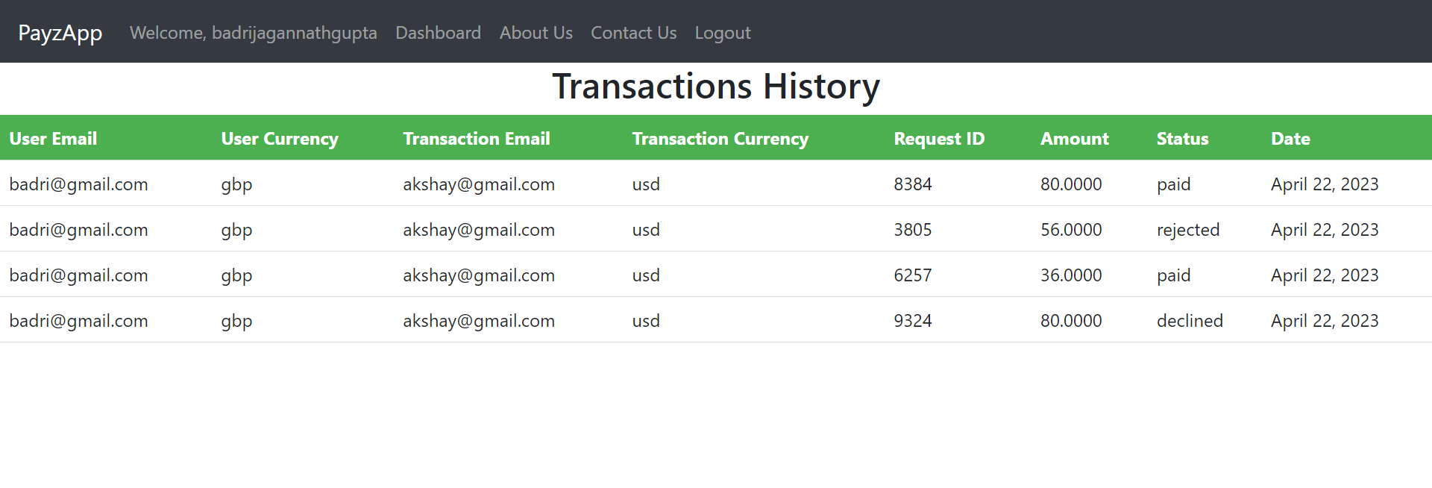

**🡪 Below screenshot shows us that user1 logged in and he has received the fund transfer from user1 as it shows the increased amount in his main balance.**

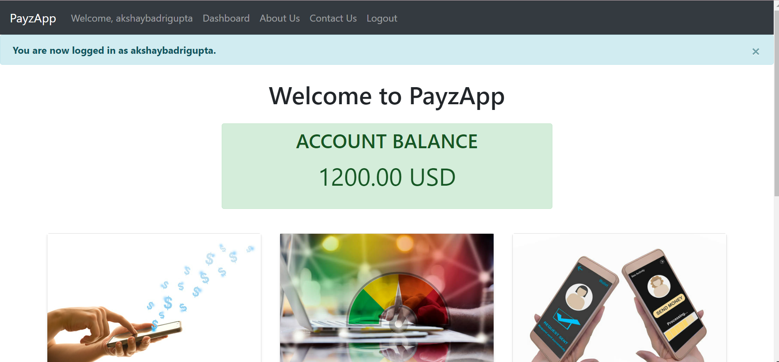

**🡪 Below screenshot shows us the final transaction history of user1 where he can view all the transactions.**

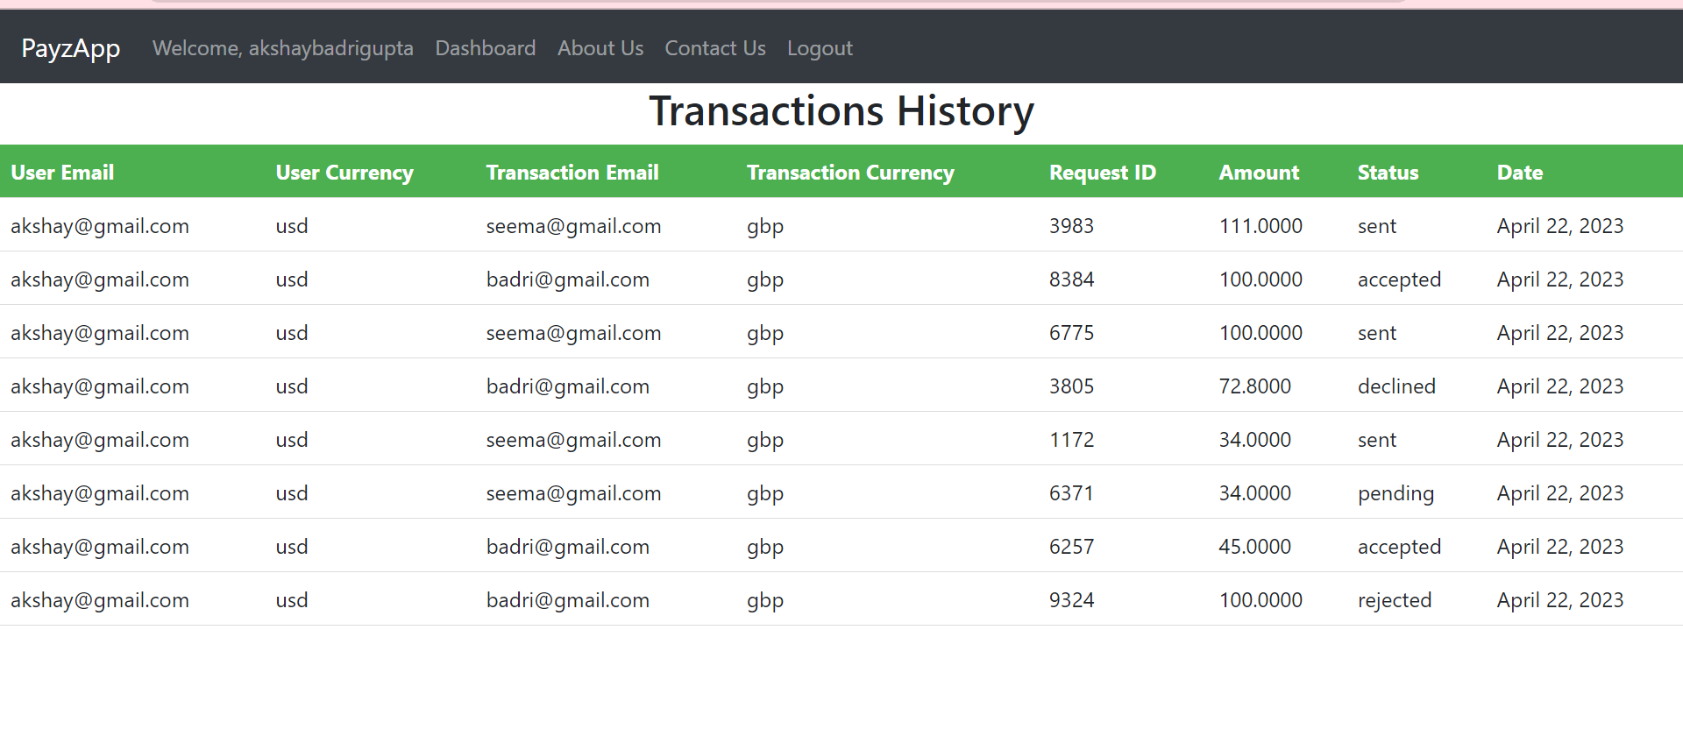

**Deployment on Amazon Ec2 machine**

**🡪 I followed below commands to deploy my code on amazon ec2 machine**

ubuntu@ip-172-31-58-193:~/django_online_payment_service_app$ sudo apt-get update

ubuntu@ip-172-31-58-193:~/django_online_payment_service_app$ git clone <https://github.com/SwatiBGupta1110/django_online_payment_service_app.git>

ubuntu@ip-172-31-58-193:~/django_online_payment_service_app$ sudo apt install python3-pip -y

ubuntu@ip-172-31-58-193:~/django_online_payment_service_app$ ls -lrt

ubuntu@ip-172-31-58-193:~/django_online_payment_service_app$ cd django_online_payment_service_app/

ubuntu@ip-172-31-58-193:~/django_online_payment_service_app$ python3 manage.py makemigrations

**🡪 I installed below packages on amazon ec2**

pip install crispy-bootstrap5

pip install django-crispy-forms

pip install django-widget-tweaks

pip install djangorestframework

pip install django-filter

pip install Werkzeug

pip install pyOpenSSL

pip install django-extensions

ubuntu@ip-172-31-58-193:~/django_online_payment_service_app$ python3 manage.py createsuperuser

ubuntu@ip-172-31-58-193:~/django_online_payment_service_app$ git pull origin master

ubuntu@ip-172-31-58-193:~/django_online_payment_service_app$ python3 manage.py runserver 0.0.0.0:8000

**🡪 Below screenshot shows us console of amazon ec2 machine where app is running**

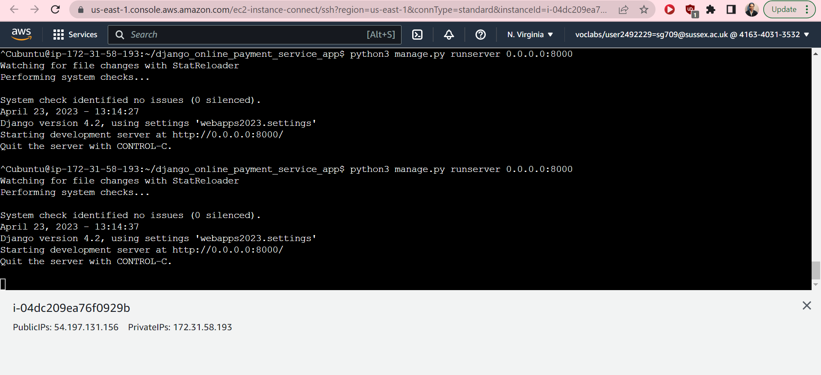

**🡪 Below screenshot shows us the Inbound rule I added so that app can run on 8000 port.**

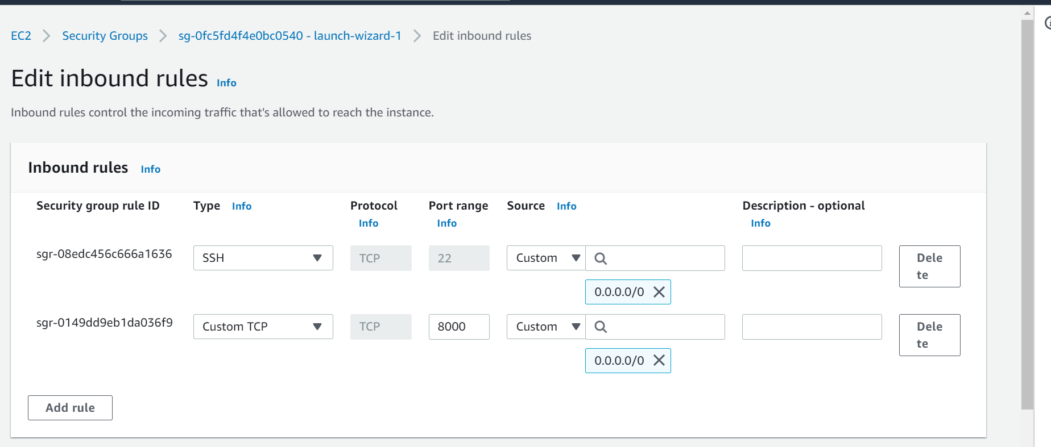

**🡪 Below screenshot shows us the login page for user which is hosted by amazon ec2 machine.**

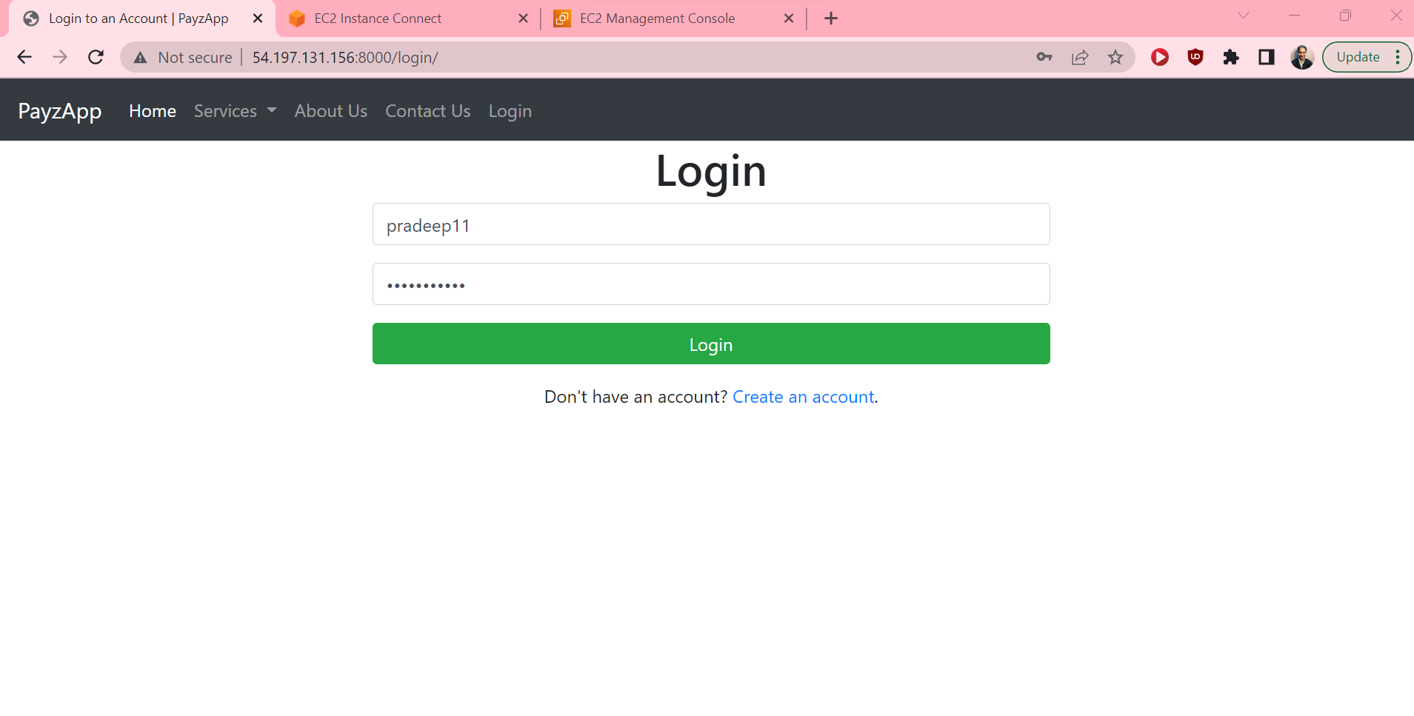

**🡪 Below screenshot shows us the dashboard page where user landed after logging to his account after deploying our webapp to amazon aws ec2 instance.**

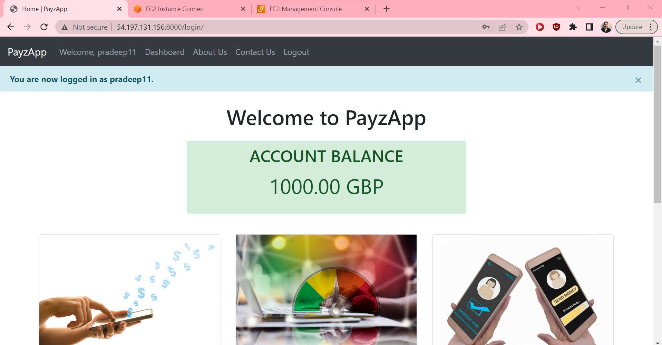

**References:**

GeeksforGeeks. (2021). *How to customize Django forms using Django Widget Tweaks ?* [online] Available at: https://www.geeksforgeeks.org/how-to-customize-django-forms-using-django-widget-tweaks/ [Accessed 22 Apr. 2023].

‌Django Project. (n.d.). *Django*. [online] Available at: <https://docs.djangoproject.com/en/4.2/>.

contributors, M.O., Jacob Thornton, and Bootstrap (n.d.). *Examples*. [online] getbootstrap.com. Available at: <https://getbootstrap.com/docs/5.3/examples/>.

getbootstrap.com. (n.d.). *Album example · Bootstrap v5.3*. [online] Available at: https://getbootstrap.com/docs/5.3/examples/album/ [Accessed 22 Apr. 2023].

getbootstrap.com. (n.d.). *Top navbar example · Bootstrap v5.3*. [online] Available at: https://getbootstrap.com/docs/5.3/examples/navbar-static/ [Accessed 22 Apr. 2023].

‌

‌

‌